Stripping away sky reflectance, waves and turbulence for benthic mapping: Imaging the seafloor not the surface.
David Hart^{1,2}, Megan Lewis³, Bertram Ostendorf⁴

¹University of Adelaide
Private Mail Bag 1, Glen Osmond, South Australia, 5064
Ph +61 8 8303 7324, Fax +61 8 8303 6717
david.hart@student.adelaide.edu.au

²Department for Environment and Heritage
GPO Box 1047, Adelaide, South Australia, 5001
Ph +61 8 8463 3944, Fax +61 8 8463 3900
hart.david@saugov.sa.gov.au

³University of Adelaide
Private Mail Bag 1, Glen Osmond, South Australia, 5064
Ph +61 8 8303 6522, Fax +61 8 8303 6717
megan.lewis@adelaide.edu.au

⁴University of Adelaide
Private Mail Bag 1, Glen Osmond, South Australia, 5064
Ph +61 8 8303 7317, Fax +61 8 8303 6717
bertram.ostendorf@adelaide.edu.au

Abstract
This paper presents the results of an airborne experiment using horizontal and vertical polarising filters on a pair of co-mounted 12.8 megapixel Canon 5D digital cameras. These cameras were mounted in the underside camera port of a light aircraft, both cameras inclined at 30 degrees off-nadir. One camera had the polarisation filter oriented vertically and the other oriented horizontally. Forward-looking, overlapping, oblique aerial photography was captured over known seagrass meadows off the Adelaide metropolitan coastline, plus inland urban water bodies. The portrait oriented field of view allowed a progression on the image from near-nadir to beyond the critical Brewster angle of 53 degrees.
Results show the removal of sky reflectance, turbulence and wave action on the vertically-oriented filter imagery compared to the horizontally-oriented filter imagery in both clear and turbid waters. For clear waters the removal of sky reflectance, waves and surface turbulence allowed visualisation of the seafloor suitable for benthic mapping in areas of seagrass. However in turbid water the removal of surface effects still did not allow the seafloor to be visualised due to multiple scatter in the body of the water. This method therefore also has application in differentiating clear and turbid waters on oblique photography.

Introduction
Sea surface reflectance of sunlight and sky is often the bane of aerial photography captured for marine benthic mapping. This surface reflectance noise shows on the resultant image as the dominant signal, masking or obliterating the light reflected from the below-water benthic surface.
Current methods to avoid this surface reflectance mainly involve planning of aerial photography flights for times of minimal wave action, off-frame sun reflectance angles (early morning, late afternoon, sun reflectance on land) and free of cloud (Hart and Cameron 1998).
This paper presents the results of the use of a camera mounted polarizing filter to remove all water surface reflectance, based on the well documented property of light to totally refract the vertical component into a refrangible medium at the Brewster angle whilst only reflecting the horizontal component. By filtering out the surface-reflected horizontal component at the camera, the resultant signal is expected to be the remaining unpolarised subsurface reflectance from the benthic substrate. The theoretical background to the experimental design (Hart et al, 2006) was presented at the 13th Australasian Remote Sensing and Photogrammetry Conference and therefore this paper follows on from that earlier paper.
Experimental Design
The null hypothesis is that “Imaging of vertically polarized photons at critical angles makes no improvement in contrast between seagrass beds and surrounding substrate.” The aim of the experiment was to disprove the null hypothesis. The imagery captured using a camera with a vertically polarizing filter is the experimental variable. The imagery captured using a camera with a horizontally polarizing filter is the experimental control.
Two 12.8 megapixel Canon 5D digital cameras were co-mounted in the camera port of a Cessna 160 aircraft VH-PJE (see figure 1). Identical Hoya 58mm Super Pro 1 Circular Polariser polarising filters were attached in front of the lens. One polarising filter was orientated such that the filter allowed only the horizontally polarised component through, whilst the other filter was oriented such that the filter allowed only the vertically polarised component through to the imaging chip.
Both cameras were mounted pointing forward from the aircraft at approximately 30 degrees from nadir with the CMOS chip oriented in portrait format. This ensured that the field of view (~60 degrees) extended from near nadir through to the Brewster angle (~53 degrees from nadir for water) and slightly beyond. This resulted in the images showing the polarisation effects at the oblique Brewster angle and progressively away towards standard nadir angle for aerial photography.
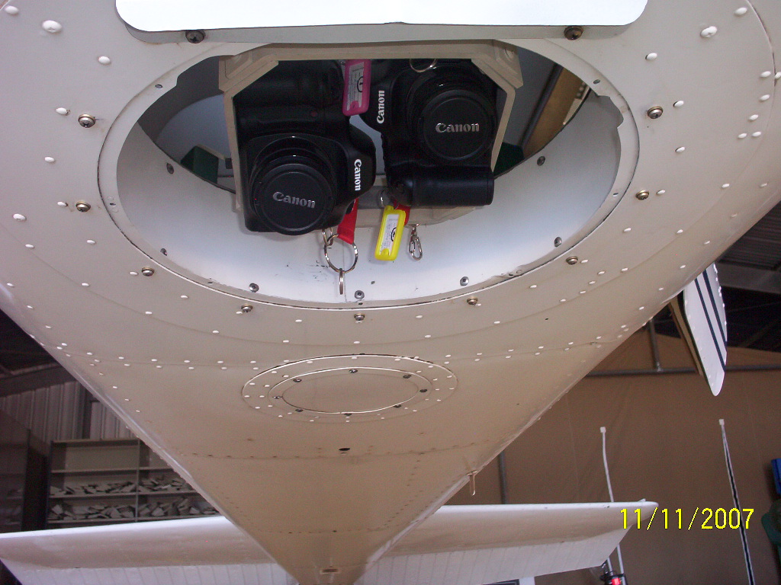
Figure 1 Dual camera mount
Image Capture
Engineering mounting took place on Sunday 11 November 2007 at the aircraft hanger at Murray Bridge (South Australia) aerodrome in preparation for the image capture flight.
On the day of the flight (Tuesday 13 November 2007) the cameras were mounted on the bracket in the aircraft. One polarization filter was adjusted to be horizontal on one camera, and the other adjusted to vertical on the other.
Conditions were optimal, with clear skies and calm conditions. Ocean turbidity was expected to be minimal due to at least ten days since the last rainfall event.
The flight was from the coast eastwards from Point Malcolm (34 deg 51.5 min, 138 deg 28.5 min) to a point seven nautical miles off-shore (34 deg 51.5 min, 138 deg 20 min). Then from that location tracking to Brighton jetty (35 deg 1.5 min, 138 deg 31 min), then the reverse course (a reverse figure 7 shape) back to Point Malcolm. An opportunistic run of photography was also captured over the Adelaide Central Business District (see figure 2).
The image capture started at 10:21am and finished at 10:52am Australian Central Daylight Time (GMT +10hr 30min). Unfortunately the GPS failed, so no positional information was captured. Overlapping imagery was successfully captured on all five runs.
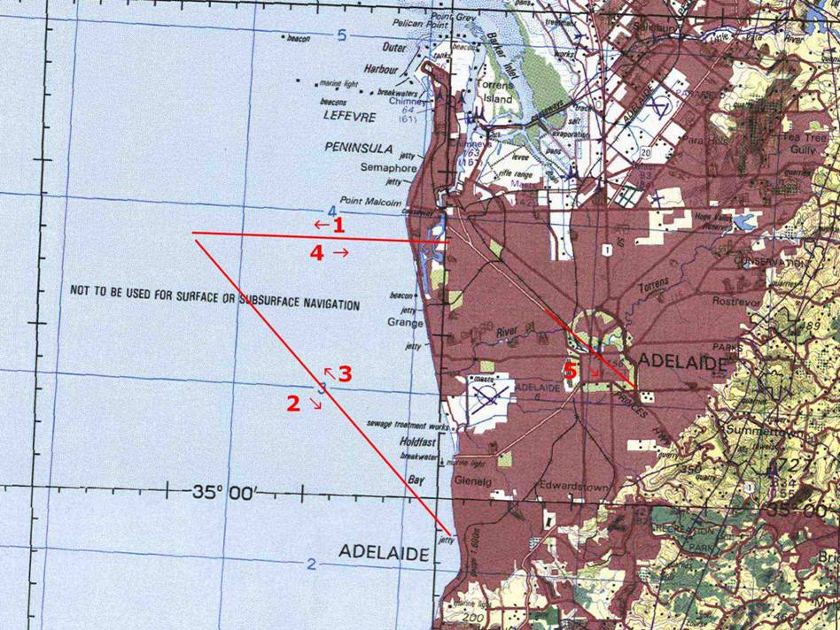
Figure 2 Flight lines
Results
Initial inspection showed little to no difference between the Horizontal (H) and Vertical (V) images when the sun is behind the aircraft (run 1). However differences are apparent when directly viewing the sun reflection (run 4).
Enlargements (figure 3 and figure 4) of the barely-submerged Point Malcolm breakwater at around the Brewster angle (top part of enlargements) show marked differences. Note the removal of nearly all wave action, including breaking waves, and sun glint. The breakwater is barely visible in the H enlargement, yet is clearly visible in the V enlargement. Dark areas further off-shore are remnant seagrass beds (Posidonia spp.) and detrital matter. Note also on the enlargement of frame 4735 the return of sun glint away from the Brewster angle (towards the bottom of the enlargement).
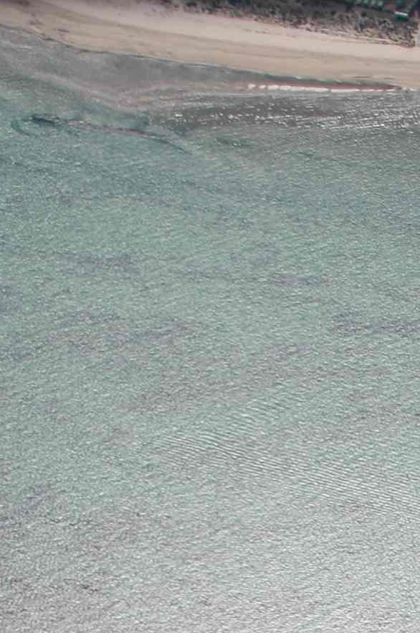
Figure 3 Horizontally polarised image
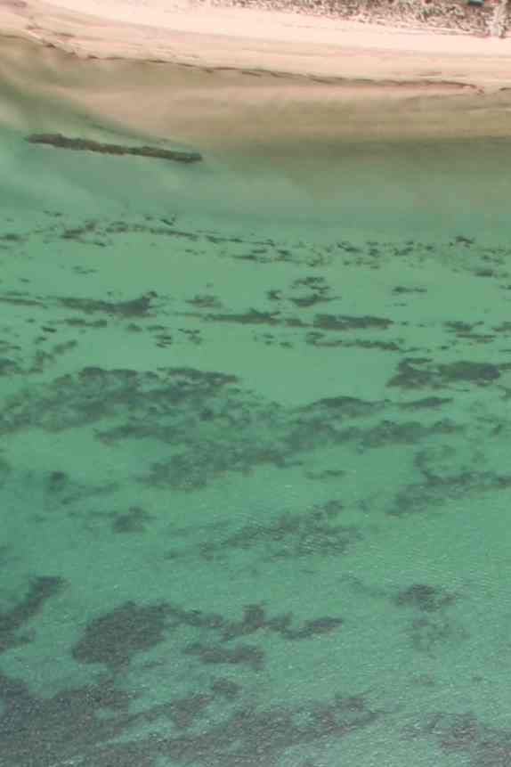
Figure 4 Vertically polarized image
Discussion
Initial inspection of the data shows that comparing the variable and control data has disproved the original null hypothesis – at least at certain sun aspects. Run 4, directly towards the sun, showed sun glint, and wave action in the horizontally polarising filtered image sufficient to mask most subsurface detail. The vertically polarising filtered imagery removed the glint, even in areas masked by breaking waves. Therefore imaging of vertically polarized photons at critical angles makes a great improvement in contrast between seagrass beds and surrounding substrate at certain geometries compared to imaging of horizontally polarized photons. (Italics indicate experimental constraints on the results).
While achieving the improvement of seagrass and substrate discrimination, this method has obvious drawbacks. The oblique angle results in reductions in scale and resolution of objects compared to standard vertical aerial photography. The oblique angles also cause underwater object displacement due to refraction which needs to be corrected if mapping is to take place (Gibson 1995). However the effect of lower dynamic range due to increased airborne path-length (Curren 1981) was not a major factor in reducing image contrast.
The method, while removing the effects of surface attributes such as sunglare, object reflection, wave action and turbulence, seems to not improve benthic contrast by removing the effects of bulk water attributes such as turbidity. However due to the removal of surface reflectance, turbidity plumes can be imaged on oblique photography using this method for water quality studies. This has yet to be trialled in non-ideal weather conditions with significant wave action.
Conclusion
The use of a vertical polarisation filter on oblique aerial photography removes surface reflection at and around the critical Brewster angle. For clear waters the removal of sky reflectance, waves and surface turbulence allowed visualisation of the seafloor suitable for benthic mapping in areas of seagrass. However in turbid water the removal of surface effects still did not allow the benthic floor to be visualised due to multiple scatter in the body of the water. This method therefore also has application in differentiating clear and turbid waters on oblique photography.
Acknowledgements
Thanks to Paul Dare (Spatial Scientific Technologies Pty Ltd) and Steve Barlow (Airspeed Pty Ltd) for image capture; Ken Clarke, Roweena Morris and the Spatial Information Group (University of Adelaide); Paul Connelly (University of South Australia); This series of experimental polarisation flights were funded by a research grant from the Flinders University of South Australia.

References
Curren, Paul, 1981, The Relationship Between Polarized Visible Light and Vegetation Amount. Remote Sensing of Environment, 11:87-92.
Gibson, D., 1995, Refraction corrections to underwater DEM heights for orthophoto production from single photos. South Australian Department for Environment and Natural Resources, Internal Report, unpublished.
Hart, D. and Cameron, J., 1998, Seagrass Change Mapping using Orthogonalised Historical Aerial Photography. 9th Austalasian Remote Sensing and Photogrammetry Conference, Sydney.
Hart, D., Lewis, M., Dare, P., and Ostendorf, B., 2006, Seeing seagrasses sidewards: marine angiosperms and the Stokes’ polarization parameters. 13th Australasian Remote Sensing and Photogrammetry Conference, Canberra.

